Place to find the open data sets (Good for the practitioner to begin analyzing the data,Googleataset ,Kaggle data set , EuropeanUnion Data sets and UN.org data sets .   
<https://www.kaggle.com/paultimothymooney/chest-xray-pneumonia>

CDLA-licensed data sets, you are under no obligation to share the model, or to share it under a specific license if you do choose to share

In this video, you’ve learned about the most common data science tasks and which open source tools are relevant to those tasks

Play video for highlighted transcript with text, One of the latest developments in the data science execution environments is called “Ray,” which has a clear focus on large-scale deep learning model training., marked from 3 minutes 50 seconds till 4 minutes 3 secondsOne of the latest developments in the data science execution environments is called “Ray,” which has a clear focus on large-scale deep learning model training.

Play video for highlighted transcript with text, The key property of Apache Spark is linear scalability., marked from 3 minutes 9 seconds till 3 minutes 13 secondsThe key property of Apache Spark is linear scalability.

Play video for highlighted transcript with text, The well known cluster-computing framework Apache Spark is among the most active Apache, marked from 2 minutes 58 seconds till 3 minutes 3 secondsThe well known cluster-computing framework Apache Spark is among the most active Apache

Play video for highlighted transcript with text, Python world, Jupyter is used more frequently., marked from 2 minutes 36 seconds till 2 minutes 41 secondsPython world, Jupyter is used more frequently.

 Add your thoughts

Data Asset eXchange

To make it easier for developers to get started with using the data sets, DAX also provides

tutorials in the form of notebooks that walk through the basics of data cleaning, pre-processing,

In the hands-on lab you’ll have a chance to explore the repository.

**Machine Learning Models**

he process by which the model learns these patterns from data is called “model training."

Once a model is trained, it can then be used to make predictions.

Machine learning models can be divided into three basic classes: supervised learning,

unsupervised learning, and reinforcement learning.

 supervised learning is used to solve regression and classification

problems.

Let’s look at an example for each problem type:

Regression models are used to predict a numeric, or “real," value.

For example, given information about past home sales, such as geographic location, size,

number of bedrooms, and sales price, you can train a model to predict the estimated sales

price for other homes with similar characteristics.

 reinforcement learning model learns the best set of actions to take,

given its current environment, in order to get the most reward over time.

This type of learning has recently been very successful in beating the best human players

in games such as go, chess, and popular strategy video games.

Deep learning typically requires very large data sets of labeled data to train a model,

is compute-intensive, and usually requires special purpose hardware to achieve acceptable

training times. Deep learning frameworks typically provide a Python API, and many support other programming

languages, such as C++ and JavaScript.

Deep learning models are implemented using popular frameworks such as TensorFlow, PyTorch,

and Keras

*Deep learning is a specialized type of machine learning.*

*It refers to a general set of models and techniques that tries to loosely emulate the way the*

*human brain solves a wide range of problems.*

*It is commonly used to analyze natural language, both spoken and text, as well as images, audio,*

*and video,*

#### Model Asset Exchange

IBM Developer, a free

open source resource for deep learning model

The MAX model-serving microservices are built and distributed as open-source Docker images.

Docker is a container platform that makes it easy to build applications and to deploy

them in a development, test, or production environment.

The Docker image source is published on GitHub and can be downloaded, customized as needed,

and used in personal or commercial environments.

The MAX model-serving microservices are built and distributed as open-source Docker images.

Docker is a container platform that makes it easy to build applications and to deploy

them in a development, test, or production environment.

The Docker image source is published on GitHub and can be downloaded, customized as needed,

and used in personal or commercial environments.

Question 3 FALSE

True or False: Open data is always distributed under a Community Data License Agreement.

GIT

"git add" moves changes from the working directory to the staging area.

"git status" allows you to see the state of your working directory and the staged snapshot

of your changes.

"git commit" takes your staged snapshot of changes and commits them to the project.

"git reset" undoes changes that you’ve made to the files in your working directory.

"git log" enables you to browse previous changes to a project.

"git branch" lets you create an isolated environment within your repository to make changes.

"git checkout" lets you see and change existing branches.

"git merge" lets you put everything back together again.

To learn how to use Git effectively and begin collaborating with data scientists around

the world, you will need to learn the essential commands.

Luckily for us, GitHub has amazing resources available to help you get started.

Go to try.github.io to download the cheat sheets and run through the tutorials.

In the following modules, we'll give you a crash course on setting up your local environment

and getting started on a project.

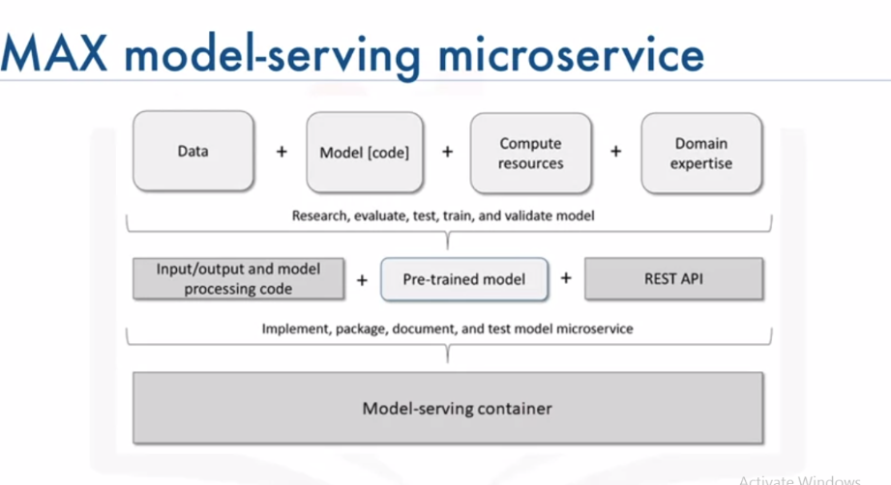

The MAX model-serving microservices are built and distributed as open-source Docker images.

Docker is a container platform that makes it easy to build applications and to deploy

them in a development, test, or production environment.

The Docker image source is published on GitHub and can be downloaded, customized as needed,

and used in personal or commercial environments.

u can deploy and run these images in a test or production environment using Kubernetes,

an open-source system for automating deployment, scaling, and management of containerized applications

in private, hybrid, or public clouds.

A popular enterprise-grade Kubernetes platform is Red Hat OpenShift, which is available on

IBM Cloud, Google Cloud Platform, Amazon Web Services, and Microsoft Azure.

T he model-serving microservices expose a REST API that developers can use to incorporatedeep learning into their applications and services. Because REST APIs can be consumed using any programming language, you can easily integrate these services into your existing ecosystem.

Each endpoint accepts application-friendly inputs, such as an image in JPG, PNG, or GIF

format, instead of a model-specific data structure. Each endpoint also generates application-friendly outputs, such as standardized JSON, which is a lightweight data-interchange format.

**we’ve introduced the Model Asset eXchange, a free and open source repository**

**for microservices that make deep learning functionality available to applications and**

**services in local and cloud environments.**

**In the lab, you will have a chance to try a model-serving microservice, explore its**

**API, and learn more about how you can leverage it from a web application and an Internet**

**of Things application.**

## Explore deep learning models

1. Open <https://developer.ibm.com/> in your web browser.  
   <https://developer.ibm.com/series/create-model-asset-exchange/>
2. View all model select Object Model   
   FROM GITHUB The repository contains everything a developer needs to manually build a customized version of the model-serving microservice.   
   **All MAX models are distributed as containerized applications, which can be deployed as a microservice in a local environment, a hybrid cloud environment or a cloud environment using Docker or Kubernetes**.

**Option to deply this model using dockeRRRRRR  
d**ocker run -it -p 5000:5000 codait/max-object-detector

OR click below using API model

<http://max-object-detector.codait-prod-41208c73af8fca213512856c7a09db52-0000.us-east.containers.appdomain.cloud/>

n the next section we’ll briefly review how applications can consume the prediction endpoint to analyze the input.

. To make it easy for developers to get started, each model comes with a set of examples. For the Object Detector model these samples include:

Curl.haxx.se

Upload the image here

<http://max-object-detector.codait-prod-41208c73af8fca213512856c7a09db52-0000.us-east.containers.appdomain.cloud/app/>